** Research & Industrial Conclave 2022: Hackathon Event**

**Problem Statement:** How to manage to contain COVID-19 in an academic residential campus in the event of outbreak?

Problems faced during outbreak:

* When we went for testing, there was more chances of getting corona because of crowd as we did not know who were positive and who were negative.
* We had to wait for a long time in queue for our turn.
* Temperature, SPo2 level and medicines status were checked 3 times a day by medical staff.
* We were not allowed to go out of hostel and positive patients could not leave to hospital. And everyone was facing food issue. We heard from our friends that food provided in hospital was not good and they did not have any other option. Juice was not provided by hospital management and patient was not able to order from outside.
* There was no tool available to manage close contacts of covid positive patients.
* If a patient’s report was coming negative, he/she has to carry all the luggage by himself/herself from hospital to respective hostel. Just recovered patient don’t have much stamina to carry their luggage’s.
* If a person wants to leave campus, he/she has to carry luggage by herself/himself as cabs were not allowed inside due to containment zone.
* For a sick person, there is no proper transportation facility to reach the hospital.
* If someone has any issue regarding anything, we did not know whom to contact.

We considered all the above problems and tried to provide an easy access for the management of covid situation in campus.

**Covid Management tool (IIT Guwahati):**

We developed a dashboard and chatbot for teams.

Database

Dashboard

Chatbot

**Stakeholders:**

CRT Team Students

Covid management team Staff

Hospitals staff etc. Others

**Applications:**

Display database data in graphs, heatmap. Raise any request from it.

Get notification for any update in DB. etc

**Advantages:**

No need to install any extra software to open dashboard and chatbot.

Dashboard can be opened in any browser.

Chatbot can be accessed through any app like facebook , Microsoft teams etc.

**Chatbot ‘YourSathi’ :**

Every student and professor are using Microsoft teams due to online classes and they all are familiar with Microsoft team’s environment. So, we developed a chatbot which can be used in teams and no extra installation is required to run chatbot on teams.

Name of chatbot is **‘YourSathi’**, It has the following options:

Write Hi, Hello, Good morning, Good evening, Good afternoon etc and send the message like we send to other contacts in Microsoft teams.

It will show below options:

**Schedule a testing appointment:** We can schedule an appointment from teams itself. It will give serial number and allotted slot. So, no need to go before scheduled time.

We can reduce the crowd at testing centre and no need to wait in the queue for a long time.

**Update medicinal status:** A patient will enter all the details in teams itself and if someone missed a medicine , management will get a notification in dashboard and appropriate actions can be taken and there is no necessity to call the patient 3 times in a day.

**Order Food:** Provide drop location and mobile number along with food item, Food will be delivered to you location.

**Request for Ambulance:** We can raise an ambulance request from teams itself and management will get notification in dashboard.

**Close contact tracking:** A positive patient will provide information regarding close contact persons and management will inform those persons.

**Request for drop service:** Provide pickup location, drop location and mobile number to get drop service.

**Raise a complaint:** A person can directly complain through this chatbot and management will get a notification in dashboard.

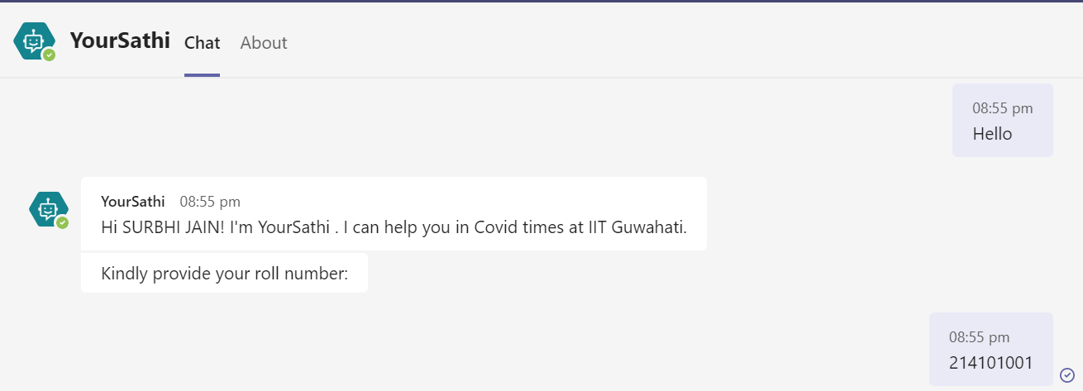

Provide your roll number once and it will record all your responses w.r.t provided roll numbers.

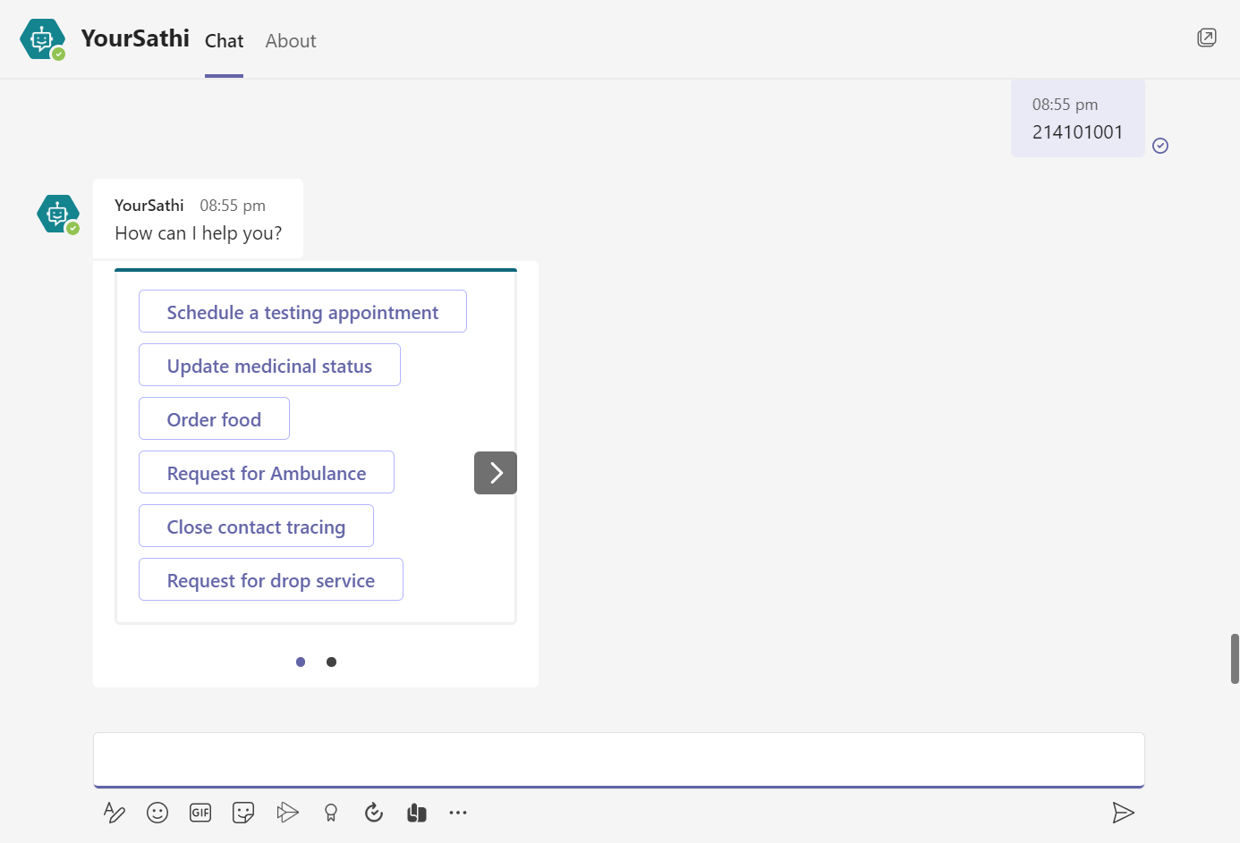

1. **Schedule a testing appointment**

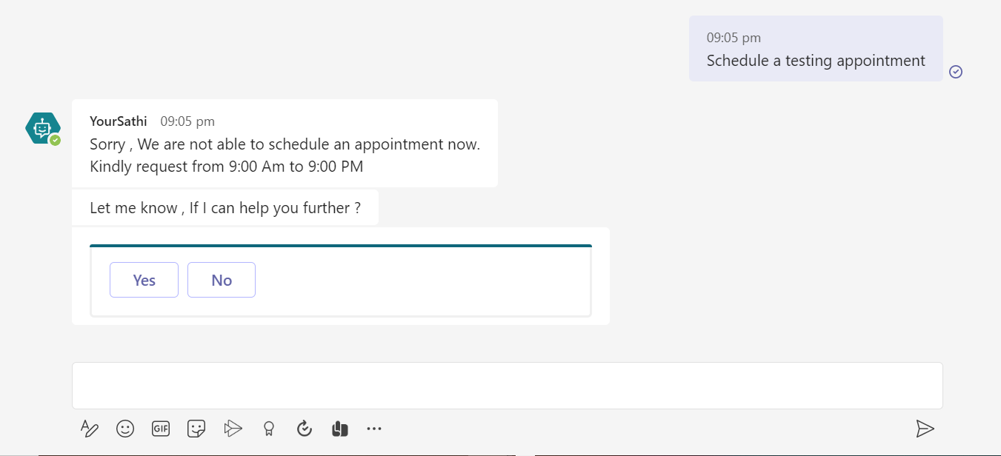

I was trying to schedule an appointment after 9:00 PM and it will not schedule an appointment as testing time is from 9:00 AM to 9:00 PM.

1. **Update medicinal status**

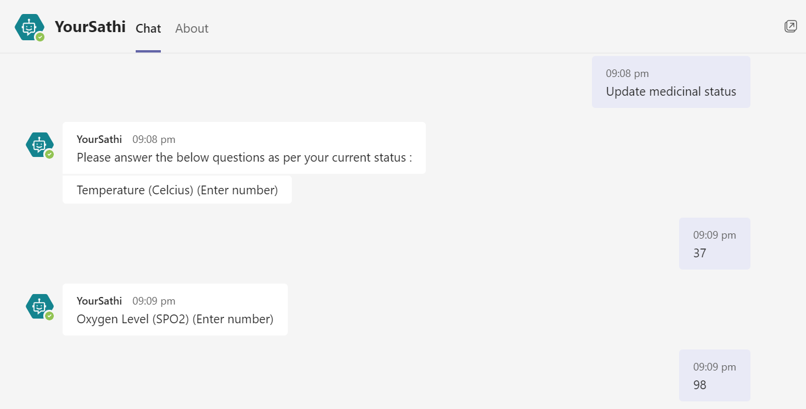

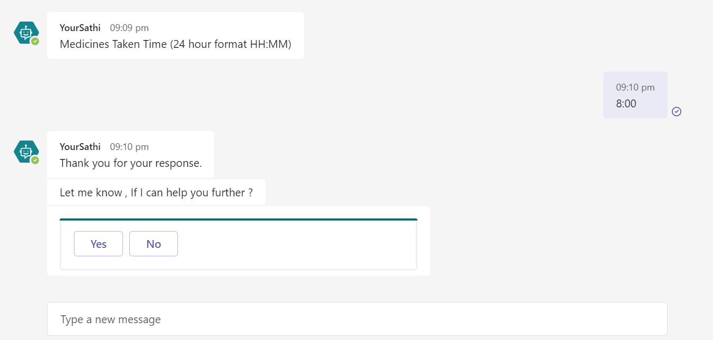

1. **Order Food:**

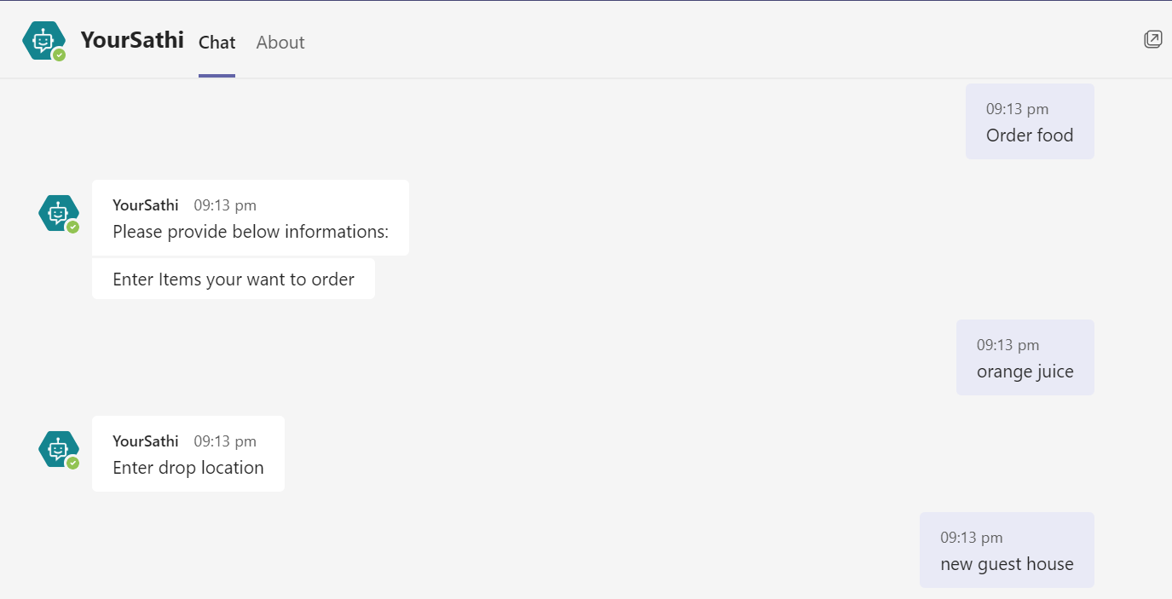

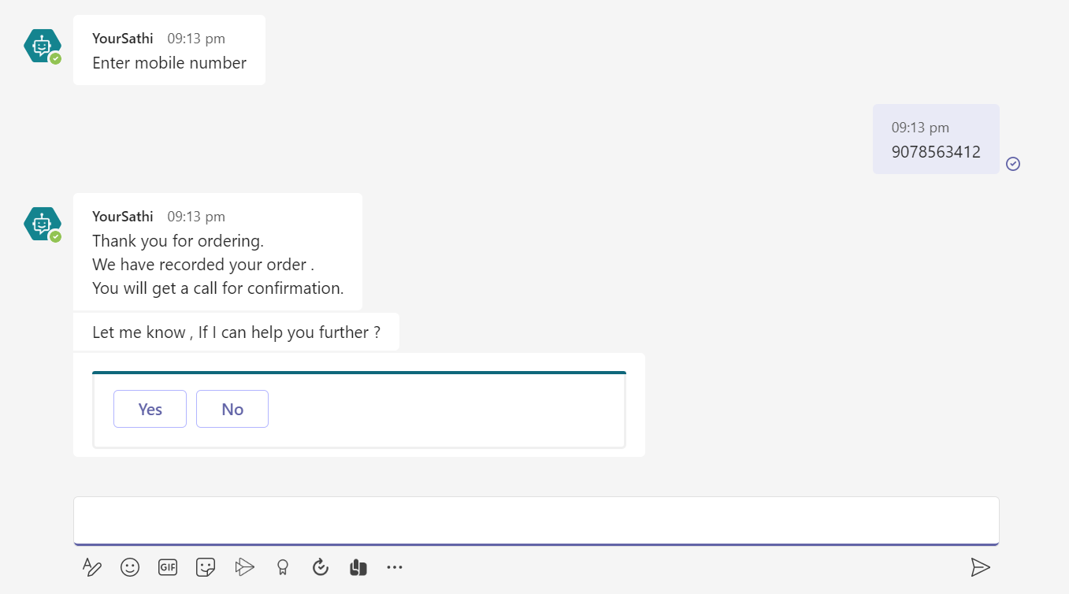

1. **Request for Ambulance**

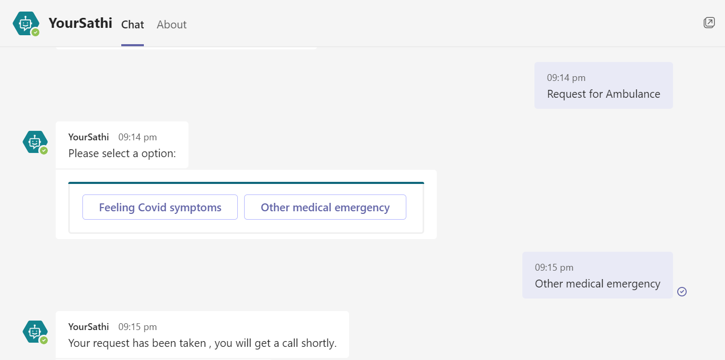

1. **Close Contact Tracking:**

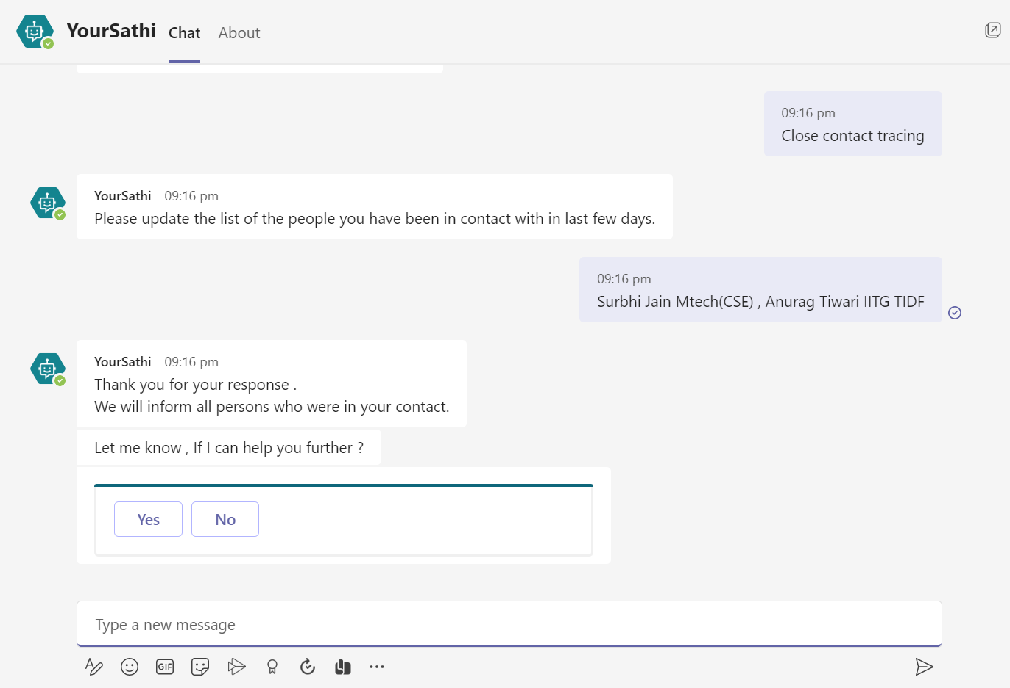

1. **Request for Drop Service:**

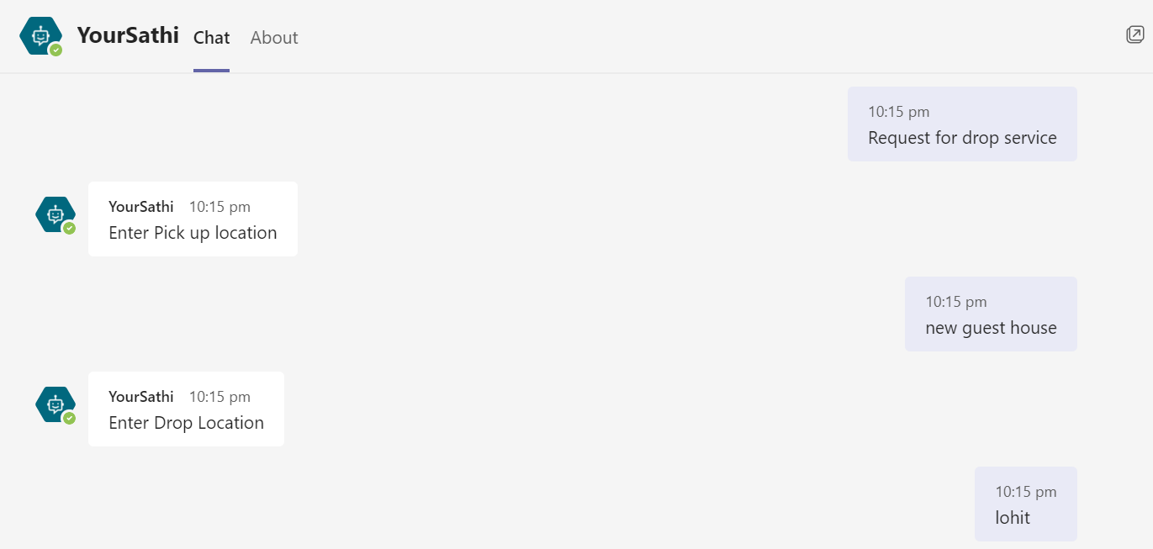

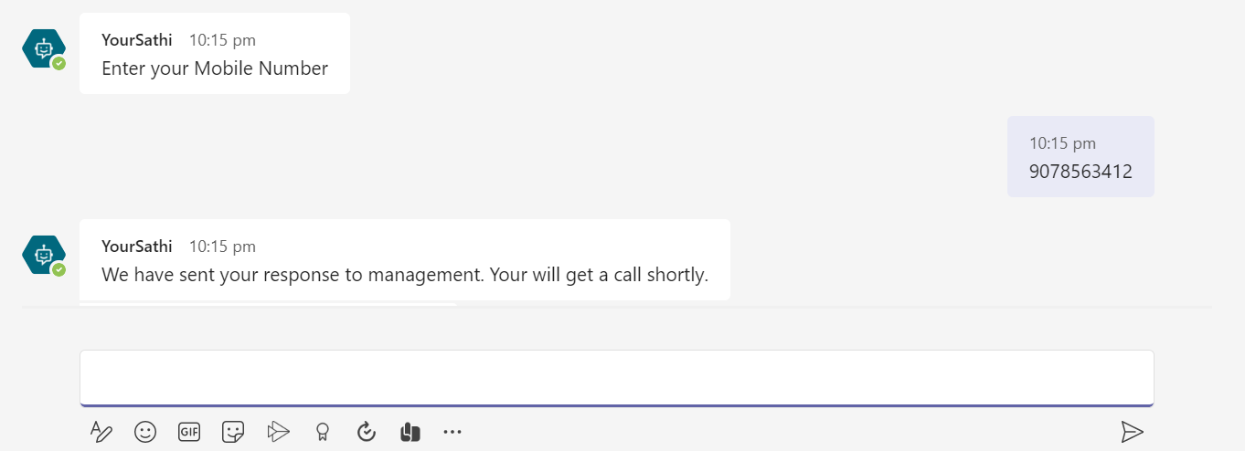

1. **Raise a complaint:**

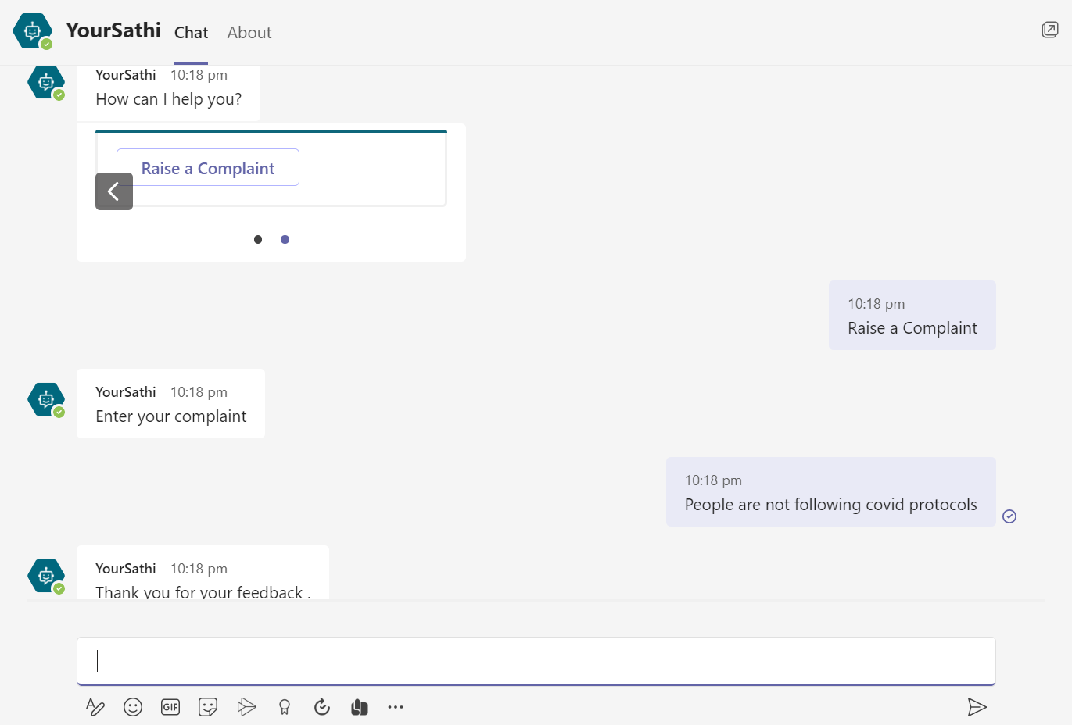

Dashboard ( IITG Covid Management Dashboard) :

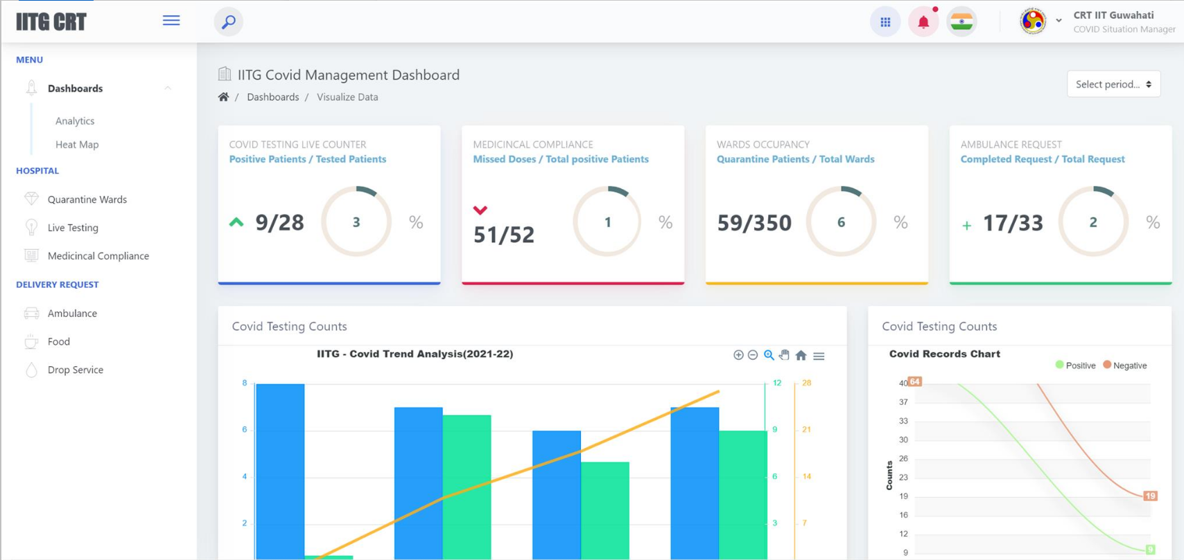

**Analytics** : It shows live counter of

* Positive patients vs Tested patients today
* Missed dose vs Total positive patients
* Quarantine patients vs Total wards
* Completed requests vs Total requests

**Heatmap** : It takes hostels longitude and latitude and show positive patients in google map.

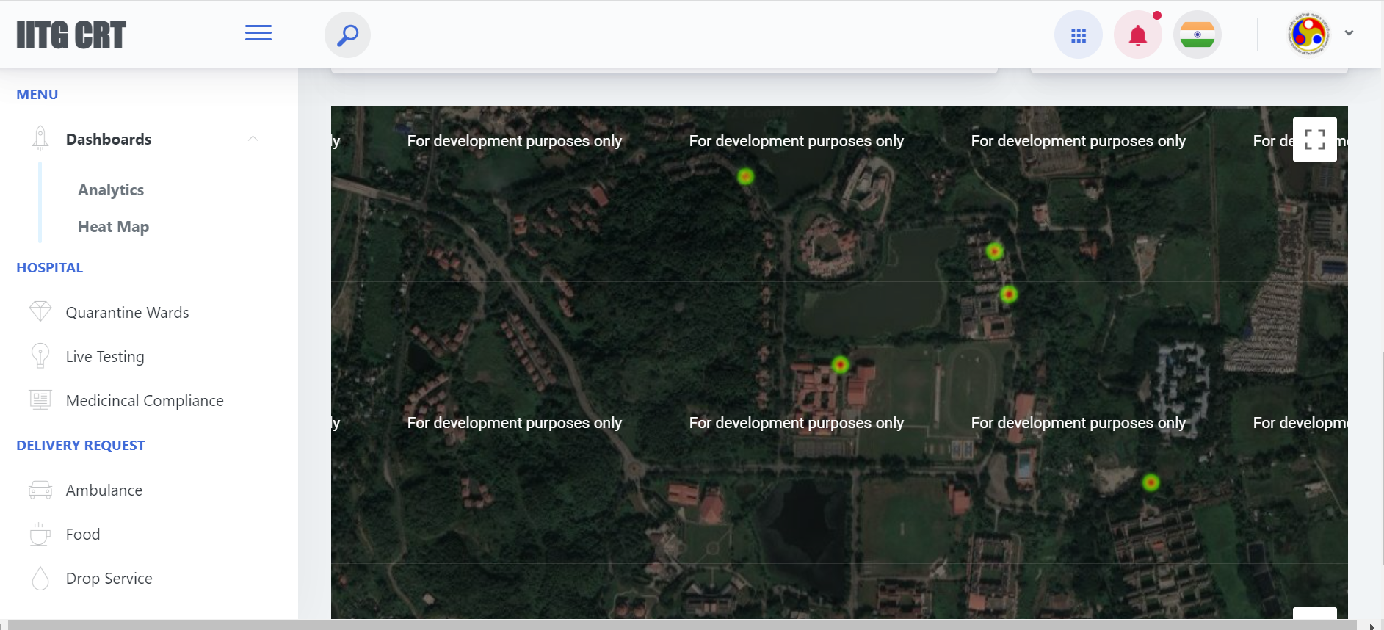

**Live testing** : It shows 2 tables

* + Persons raised a testing schedule
  + Total positive patients list

**Medicinal Compliance:** It shows medicinal status of all positive patients.

**Delivery Request:** Show the persons details who raise an ambulance request , food request and drop request.

**Mail Automation**: It will send the mail directly to all persons like we get CRT mails daily.

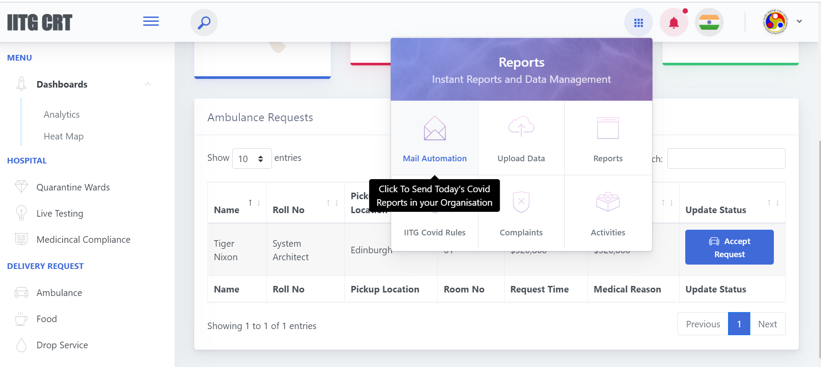

Upload resident’s data:

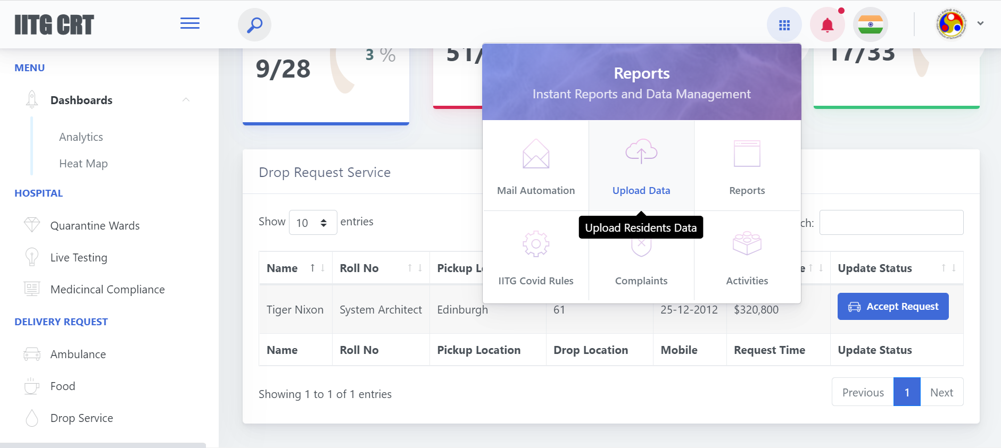

Download the excel template, fill the data in that excel and upload that excel.

There are some more features in dashboard.

**Thank you.**